SPI Bus interface
Introduction:
- Serial to Peripheral Interface (SPI) is a hardware/firmware communications protocol developed by Motorola and later adopted by others in the industry. Microwire of National Semiconductor is same as SPI. Sometimes SPI is also called a "four wire" serial bus.
- The Serial Peripheral Interface or SPI bus is a synchronousserial data link, a de facto standard, named by Motorola, that operates in full duplex mode. It is used for short distance, single master communication, for example in embedded systems, sensors, and SD cards.
- The Serial Peripheral Interface or SPI-bus is a simple 4-wire serial communications interface used by many microprocessor/microcontroller peripheral chips that enables the controllers and peripheral devices to communicate each other. Even though it is developed primarily for the communication between host processor and peripherals, a connection of two processors via SPI is just as well possible.
- The SPI bus, which operates at full duplex (means, signals carrying data can go in both directions simultaneously), is a synchronous type data link setup with a Master / Slave interface and can support up to 1 megabaud or 10Mbps of speed. Both single-master and multi-master protocols are possible in SPI. But the multi-master bus is rarely used and look awkward, and are usually limited to a single slave.
- The SPI Bus is usually used only on the PCB. There are many facts, which prevent us from using it outside the PCB area. The SPI Bus was designed to transfer data between various IC chips, at very high speeds. Due to this high-speed aspect, the bus lines cannot be too long, because their reactance increases too much, and the Bus becomes unusable. However, its possible to use the SPI Bus outside the PCB at low speeds, but this is not quite practical.
- The peripherals can be a Real Time Clocks, converters like ADC and DAC, memory modules like EEPROM and FLASH, sensors like temperature sensors and pressure sensors, or some other devices like signal-mixer, potentiometer, LCD controller, UART, CAN controller, USB controller and amplifier.

SPI Speed :-
- Speed is decidec by slave devices but Max speed 10 Mbps.

SPI Standard :-
- The SPI bus is a de facto standard.
- However, the lack of a formal standard is reflected in a wide variety of protocol options. Different word sizes are common. Every device defines its own protocol, including whether or not it supports commands at all. Some devices are transmit-only; others are receive-only. Chip selects are sometimes active-high rather than active-low. Some protocols send the least significant bit first.
- Some devices even have minor variances from the CPOL/CPHA modes described.
- Sending data from slave to master may use the opposite clock edge as master to slave. Devices often require extra clock idle time before the first clock or after the last one, or between a command and its response. Some devices have two clocks, one to read data, and another to transmit it into the device. Many of the read clocks run from the chip select line.
- Many SPI chips only support messages that are multiples of 8 bits. Such chips can not interoperate with the JTAG or SGPIO protocols, or any other protocol that requires messages that are not multiples of 8 bits.
- There are also hardware-level differences. Some chips combine MOSI and MISO into a single data line (SI/SO); this is sometimes called 'three-wire' signaling (in contrast to normal 'four-wire' SPI). Another variation of SPI removes the chip select line, managing protocol state machine entry/exit using other methods; this is not usually called three-wire though. Anyone needing an external connector for SPI defines their own: UEXT, JTAG connector, Secure Digital card socket, etc. Signal levels depend entirely on the chips involved.

Data and control lines of the SPI and the basic connection:-
- An SPI protocol specifies 4 signal wires.
1. Master Out Slave In (MOSI) - MOSI signal is generated by Master, recipient is the Slave.
2. Master In Slave Out (MISO) - Slaves generate MISO signals and recipient is the Master.
3. Serial Clock (SCLK or SCK) - SCLK signal is generated by the Master to synchronize data transfers between the master and the slave.
4. Slave Select (SS) from master to Chip Select (CS) of slave - SS signal is generated by Master to select individual slave/peripheral devices. The SS/CS is an active low signal.
- There may be other naming conventions such as :
SCLK :------ SCK, CLK.
MOSI : SIMO, SDO (for master devices), SDI(for slave devices), DO, DOUT, SI, MTSR.
MISO : SOMI, SDO (for slave devices ), SDI(for master devices), DI, DIN, SO, MRST.
SS : nCS, CS, CSB, CSN, nSS, STE, SYNC.
- 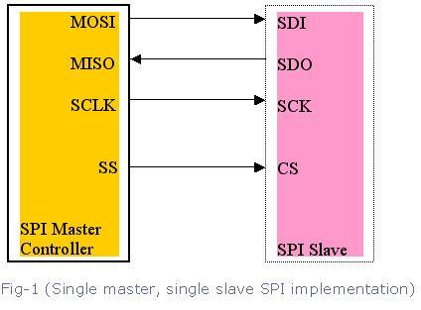Among these four logic signals, two of them MOSI & MISO can be grouped as data lines and other two SS & SCLK as control lines.
- As we already know, in SPI-bus communication there can be one master with multiple slaves. In single-master protocol, usually one SPI device acts as the SPI Master and controls the data flow by generating the clock signal (SCLK) and activating the slave it wants to communicate with slave-select signal (SS), then receives and or transmits data via the two data lines. A master, usually the host micro controller, always provides clock signal to all devices on a bus whether it is selected or not.
- The usage of these each four pins may depend on the devices. For example, SDI pin may not be present if a device does not require an input (ADC for example), or SDO pin may not be present if a device does not require an output (LCD controllers for example). If a microcontroller only needs to talk to 1 SPI Peripheral or one slave, then the CS pin on that slave may be grounded. With multiple slave devices, an independent SS signal is needed from the master for each slave device.
How do they communicate:
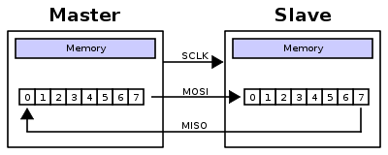
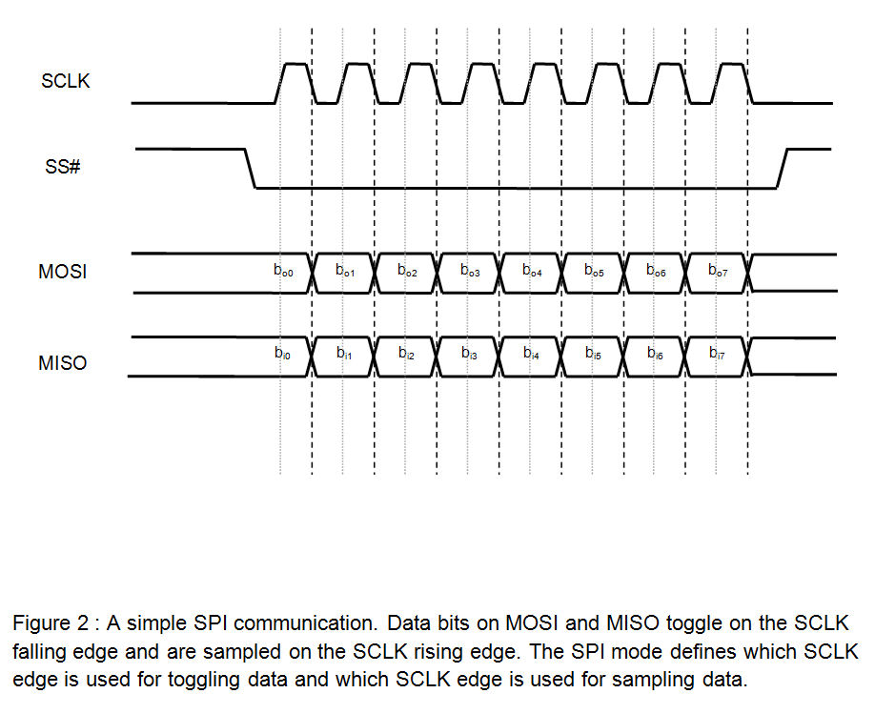

- The communication is initiated by the master all the time. The master first configures the clock, using a frequency, which is less than or equal to the maximum frequency that the slave device supports. The master then select the desired slave for communication by pulling the chip select (SS) line of that particular slave-peripheral to "low" state. If a waiting period is required (such as for analog-to-digital conversion) then the master must wait for at least that period of time before starting to issue clock cycles.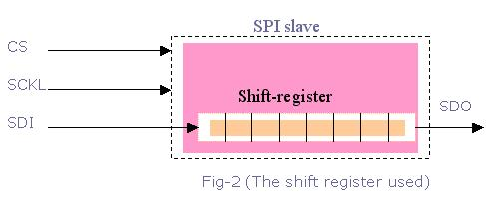
The slaves on the bus that has not been activated by the master using its slave select signal will disregard the input clock and MOSI signals from the master, and must not drive MISO. That means the master selects only one slave at a time.
Most devices/peripherals have tri-state outputs, which goes to high impedance state (disconnected) when the device is not selected. Devices without this tri-state outputs cannot share SPI bus with other devices, because such slave's chip-select may not get activated.
A full duplex data transmission can occur during each clock cycle. That means the master sends a bit on the MOSI line; the slave reads it from that same line and the slave sends a bit on the MISO line; the master reads it from that same line.
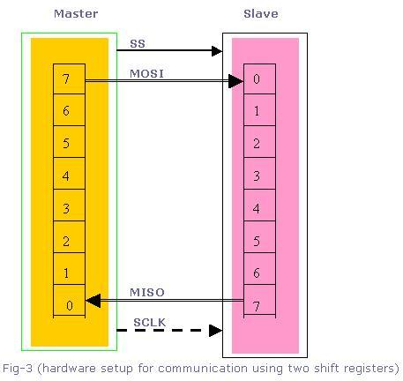
Data transfer is organized by using Shift register with some given word size such as 8- bits (remember, its not limited to 8-bits), in both master and slave. They are connected in a ring. While master shifts register value out through MOSI line, the slave shifts data in to its shift register.
Data are usually shifted out with the MSB first, while shifting a new LSB into the same register. After that register has been shifted out, the master and slave have exchanged their register values. Then each device takes that value and does the necessary operation with it (for example, writing it to memory). If there are more data to be exchanged, the shift registers are loaded with new data and the process is repeated. When there are no more data to be transmitted, the master stops its clock. Normally, it then rejects the slave.
There is a "multiple byte stream mode" available with SPI bus interface. In this mode the master can shift bytes continuously. In this case, the slave select (SS) is kept low until all stream process gets finished.
SPI devices sometimes use another signal line to send an interrupt signal to a host CPU. Some of the examples for these type of signals are pen-down interrupts from touch-screen sensors, thermal limit alerts from temperature sensors, alarms issued by real time clock chips, and headset jack insertions from the sound codec in a cell phone.
Significance of the clock polarity and phase:

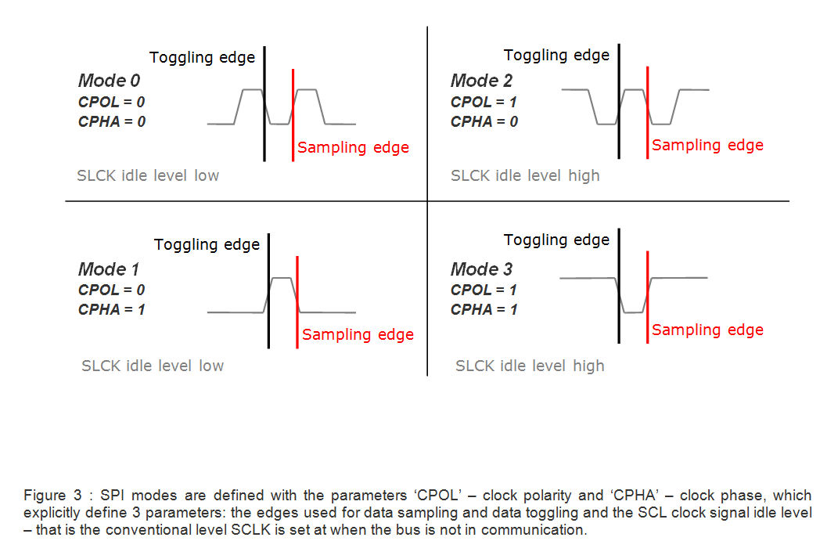
Another pair of parameters called clock polarity (CPOL) and clock phase (CPHA) determine the edges of the clock signal on which the data are driven and sampled.
That means, in addition to setting the clock frequency, the master must also configure the clock polarity (CPOL) and phase (CPHA) with respect to the data. Since the clock serves as synchronization of the data communication, there are four possible modes that can be used in an SPI protocol, based on this CPOL and CPHA.
SPI Mode | CPOL | CPHA
0 | 0 | 0
1 | 0 | 1
2 | 1 | 0
3 | 1 | 1

If the phase of the clock is zero (i.e. CPHA = 0) data is latched at the rising edge of the clock with CPOL = 0, and at the falling edge of the clock with CPOL = 1.
If CPHA = 1, the polarities are reversed. Data is latched at the falling edge of the clock with CPOL = 0, and at the rising edge with CPOL = 1.
The micro-controllers allow the polarity and the phase of the clock to be adjusted. A positive polarity results in latching data at the rising edge of the clock. However data is put on the data line already at the falling edge in order to stabilize. Most peripherals, which can only be slaves, work with this configuration. If it should become necessary to use the other polarity, transitions are reversed.
Different types of configurations:-
Suppose a master-microcontroller needs to talk to multiple SPI Peripherals. There are 2 ways to set things up:
- Cascaded slaves or daisy-chained slaves
- Independent slaves or parallel configuration

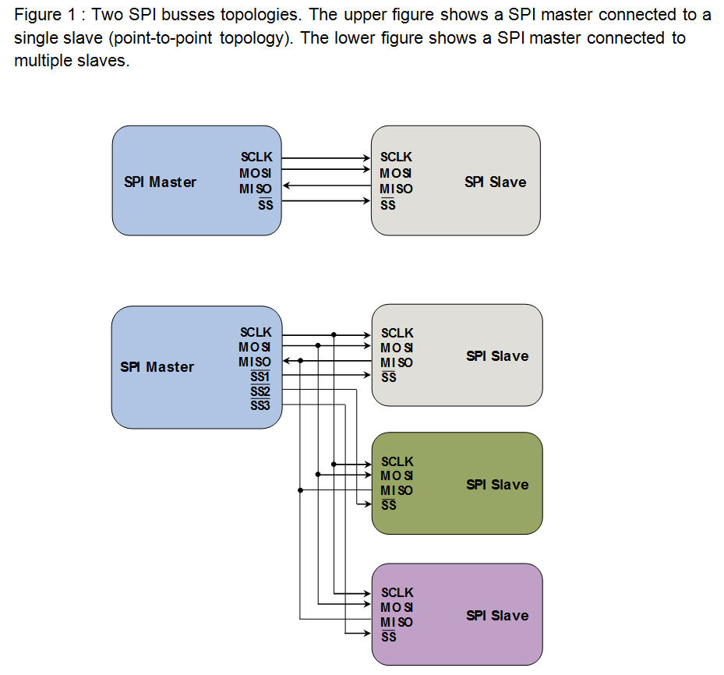

Daisy-chained slave configuration:
In cascaded slave configuration, all the clock lines (SCLK) are connected together. And also all the chip select (CS) pins are connected together. The data flows out the microcontroller, through each peripheral in turn, and back to the microcontroller. The data output of the preceding slave-device is tied to the data input of the next, thus forming a wider shift register. So the cascaded slave-devices are evidently looked at as one larger device and receive therefore the same chip select signal. This means, only a single SS line is required from the master, rather than a separate SS line for each slave.
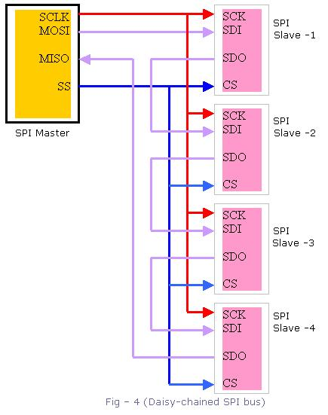

But we have to remember that the daisy-chain will not work with devices which support or require multiple bytes operation.
Independent slave configuration:
This is the typical SPI-bus configuration with one SPI-master and multiple slaves/peripherals. In this independent or parallel slave configuration,
1. All the clock lines (SCLK) are connected together.
2. All the MISO data lines are connected together.
3. All the MOSI data lines are connected together.
4. But the Chip Select (CS) pin from each peripheral must be connected to a separate Slave Select (SS) pin on the master-microcontroller.
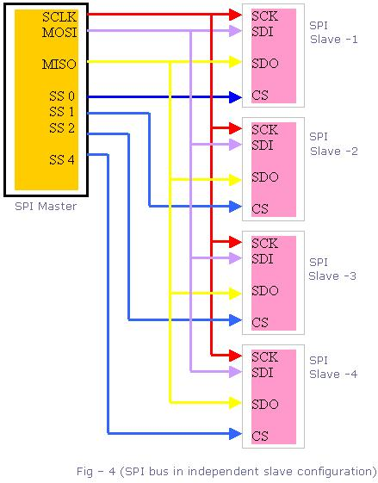
Queued Serial Peripheral Interface (QSPI) :-
The queued serial peripheral interface (QSPI) is another type of SPI controller, not another bus type. Or in other words it is just an extension to the SPI-bus.
The difference is that it uses a data queue with programmable queue pointers that allow some data transfers without CPU intervention. It also has a wrap-around mode that allows continuous transfers to and from the queue with no CPU intervention. As a result, the peripherals or the slaves appear to the CPU as memory-mapped parallel devices. This feature is useful in applications such as control of an Analog to Digital converter.
The QSPI has got some more programmable features like chip selects and transfer length/delay.
Microwire :-
Microwire, often spelled μWire, is essentially a predecessor of SPI and a trademark of National Semiconductor. It's a strict subset of SPI: half-duplex, and using SPI mode 0. Microwire chips tend to need slower clock rates than newer SPI versions; perhaps 2 MHz vs. 20 MHz. Some Microwire chips also support a three-wire mode, which fits neatly with the restriction to half-duplex.
Microwire/Plus :-
Microwire/Plus is an enhancement of Microwire and features full-duplex communication and support for SPI modes 0 and 1. There was no specified improvement in serial clock speed.
Three-wire serial buses :-
As mentioned, one variant of SPI uses single bidirectional data line (slave out/slave in, called SISO) instead of two unidirectional ones (MOSI and MISO). This variant is restricted to a half duplex mode. It tends to be used for lower performance parts, such as small EEPROMs used only during system startup and certain sensors, and Microwire. Few SPI master controllers support this mode; although it can often be easily bit-banged in software.
Multi I/O SPI:-
As opposed to three-wire serial buses, multi I/O SPI uses multiple parallel data lines (e.g., IO0 to IO3) to increase throughput. Dual I/O SPI using two data lines has comparable throughput to fast single I/O (MISO/MOSI). Quad I/O SPI using four data lines has approximately double the throughput.[12] Multi I/O SPI devices tend to be half duplex similar to three-wire devices to avoid adding too many pins. These serial memory devices combine the advantage of more speed with reduced pin count as compared to parallel memory.
mSPI :-
mSPI (mini-SPI) is a modification initially developed byDimitech for their programmable modules. Unlike the standard SPI, four signal lines are always required no matter of the number of slave devices. Its overall simplicity allows the use of standard SPI controllers with a very thin software layer.
All slave devices share the same SS (Slave Select; active low) line, along with the other three SPI signals: SCLK, MOSI and MISO. Additionally all slave devices normally have their MISO line disconnected from the bus in a high impedance state. As in the standard SPI, begin of transmission is marked by the activation of the SS line low and the end is marked by its return to high. mSPI requires the bus master to issue a "slave address" (typically 8 bits) as mandatory first word in every transmission. Since all slave devices share the same SS line, the address word will be received by all of them at the same time. From that point further, only the device with the specified address will connect its MISO line to the bus and start communicating, while all other slave devices will ignore any data and wait for a new start of transmission and address. mSPI solves some of the basic disadvantages of the standard SPI at the expense of a slight decrease in the overall communication speed due to the initial addressing.
Intel Enhanced Serial Peripheral Interface Bus:-
Intel is currently developing a successor to its Low Pin Count (LPC) bus that it calls the Enhanced Serial Peripheral Interface Bus, or eSPI for short. Intel aims to allow the reduction in the number of pins required on motherboards compared to systems using LPC, have more available throughput than LPC, reduce the working voltage to 1.8 volts to facilitate smaller chip manufacturing processes, allow eSPI peripherals to share SPI flash devices with the host (the LPC bus did not allow firmware hubs to be used by LPC peripherals), tunnel previous out-of-band pins through the eSPI bus, and allow system designers to trade off cost and performance.
The eSPI bus can either be shared with SPI devices to save pins or be separate from the SPI bus to allow more performance, especially when eSPI devices need to use SPI flash devices.

SPI Vs SSP :-
A Synchronous Serial Port (SSP) is a controller that supports the Serial Peripheral Interface (SPI), 4-wire Synchronous Serial Interface (SSI), and Microwire serial buses. A SSP uses a master-slave paradigm to communicate across its connected bus.
SSP (Synchronous Serial Port) is the module. SPI is the protocol.
SSP has a FIFO, and automatic chip select control, whereas the SPI has neither of these, so using the FIFO, the SSP could have a faster throughput at the same clock
rate.
SGPIO :-
SGPIO is essentially another (incompatible) application stack for SPI designed for particular backplane management activities.SGPIO uses 3-bit messages.

SPI Interrupts :-
SPI devices sometimes use another signal line to send an interrupt signal to a host CPU. Examples include pen-down interrupts from touchscreen sensors, thermal limit alerts from temperature sensors, alarms issued by real time clock chips,SDIO, and headset jack insertions from the sound codec in a cell phone. Interrupts are not covered by the SPI standard; their usage is neither forbidden nor specified by the standard.
Advantages of SPI :-
1. Full duplex communication
2. Higher throughput than I²C protocol
3. Not limited to 8-bit words in the case of bit-transferring
4. Arbitrary choice of message size, contents, and purpose
5. Simple hardware interfacing
6. Typically lower power requirements than I²C due to less circuitry.
7. No arbitration or associated failure modes.
8. Slaves use the master's clock, and don't need precision oscillators.
9. Transceivers are not needed.
10. At most one "unique" bus signal per device (CS); all others are shared
Disadvantages of SPI:-
1. Requires more pins on IC packages than I²C
2. No in-band addressing. Out-of-band chip select signals are required on shared busses.
3. No hardware flow control
4. No slave acknowledgment
5. Multi-master busses are rare and awkward, and are usually limited to a single slave.
6. Without a formal standard, validating conformance is not possible
7. Only handles short distances compared to RS-232, RS-485, or CAN.

Applications of SPI:-
- Most system-on-a-chip processors, both with higher end 32-bit processors such as those using ARM, MIPS, or PowerPC and other microcontrollers such as the AVR, PIC, and MSP430. These chips usually include SPI controllers capable of running in either master or slave mode.
- In-system programmable AVR controllers (including blank ones) can be programmed using an SPI interface.
- Chip or FPGA based designs sometimes use SPI to communicate between internal components.
- Sensors: temperature, pressure, ADC, touchscreens, video game controllers
- Control devices: audio codecs, digital potentiometers, DAC
- Camera lenses: Canon EF lens mount
- Communications: Ethernet, USB, USART, CAN, IEEE 802.15.4, IEEE 802.11, handheld video games
- Memory: flash and EEPROM
- Real-time clocks
- LCD, sometimes even for managing image data
- Any MMC or SD card (including SDIO variant)
- JTAG interface also available in SPI.

Development tools :-
Host adapters :-
- An SPI host adapter lets the user play the role of a master on an SPI bus directly from PC. They are used for embedded systems, chips (FPGA/ASIC/SoC) and peripheral testing, programming and debugging.
- The key parameters of SPI adapters are: the maximum supported frequency for the serial interface, command-to-command latency and the maximum length for SPI commands. It is possible to find SPI adapters on the market today that support up to 100 MHz serial interfaces, with virtually unlimited access length.
- SPI protocol being a de facto standard, some SPI host adapters also have the ability of supporting other protocols beyond the traditional 4-wires SPI (for example, support of quad-SPI protocol or other custom serial protocol that derive from SPI.
- There are a number of USB hardware solutions to provide computers, running Linux, Mac, or Windows, SPI master and/or slave capabilities. Many of them also provide scripting and/or programming capabilities (Visual Basic, C/C++, VHDL etc.).
Examples of SPI adapters:-

Manufacturer | SPI host adapter | Host bus | Bus protocol support | Max frequency
Corelis | BusPro-S | USB | SPI, dual/quad | 60 MHz
National Instruments | USB-8542 | USB | I²C, SPI | 50 MHz
Total Phase | Cheetah | USB | SPI | 40 MHz
Microchip | MCP2210 Kit | USB | SPI | 12 MHz
Byte Paradigm | SPI Storm | USB | SPI, dual/quad, custom | 100 MHz

Protocol analyzers :-

SPI protocol analyzers are tools which sample an SPI bus and decode the electrical signals to provide a higher-level view of the data being transmitted on a specific bus.

Oscilloscopes :-

Every major oscilloscope vendor offers oscilloscope-based triggering and protocol decoding for SPI. Most support 2-, 3-, and 4-wire SPI. The triggering and decoding capability is typically offered as an optional extra. SPI signals can be accessed via analog oscilloscope channels or with digital MSO channels.

Logic analyzers :-

When developing and/or troubleshooting the SPI bus, examination of hardware signals can be very important. Logic analyzers are tools which collect, analyze, decode, store signals so people can view the high-speed waveforms at their leisure. Logic analyzers display time-stamps of each signal level change, which can help find protocol problems. Most logic analyzers have the capability to decode bus signals into high-level protocol data and show ASCII data.

